Maths and English Activities

Expected Daily Maths Task | White Rose Maths  Daily lessons with a video and worksheet for every year group. This website provides a teaching lesson, work and answers for parents.  Year 3 website link –  https://whiterosemaths.com/homelearning/year-3/  Year 4 website link  https://whiterosemaths.com/homelearning/year-4/ | Year 3 Objectives  Monday – Compare capacity  Tuesday – Add and subtract capacity  Wednesday – Pictograms  Thursday – Bar charts  Friday – Problem Solving Challenge  Year 4 Objectives  Monday – Lines of symmetry  Tuesday – Complete a symmetric figure  Wednesday – Describe position  Thursday – Draw on a grid  Friday – Problem Solving Challenge
 | TT Rockstars  https://play.ttrockstars.com/auth/school/student | Beat your score! Practice your times tables daily.
Additional Weekly Maths Task | My Maths  https://login.mymaths.co.uk/login | Fancy revising previous learning from the year? On this website, teachers can monitor what work you have completed and set more. This in mainly consolidation of learning from earlier in the year.
Daily English Task | Oak National Academy  https://www.thenational.academy/online-classroom/year-3/english/#subjects  https://www.thenational.academy/online-classroom/year-4/english/#subjects | Monday – The Story of the Banana Reading Comprehension  Tuesday – Thursday Oak National Academy lesson sequence
 | Bedrock Learning  https://app.bedrocklearning.org/ | Continue to work your way through this fantastic on-line platform.
Additional Weekly English Task | Year 3  https://teaching.homelearning.outwood.com/primary/year-3  Year 4  https://teaching.homelearning.outwood.com/primary/year-4 | SPAG and reading tasks can be found on this on-line platform. Explore and work through at your own pace.
Spellings | Year 3  Word families based on the root words ‘press’ and ‘vent’  Year 4  Words that end in –ar and -er  Resources are available on the school website | Practise your weekly spellings, set by your class teacher, using a PowerPoint presentation, fun activity and a look, cover, write check task.
Optional Summer Project Activities
The activities below are designed and planned to take place over many weeks in the style of ‘projects.’
Project 1: Theme Park of Dreams  Have you ever dreamt of running your own theme park? This project is perfect for you!  You will need to plan, cost and market a theme park of your own design. Work through the PowerPoint and activity sheets, lesson by lesson, in order to take the real-life process that would be undertaken when starting your own theme park business. | Project 2: Anywhere Island  A fantastic project that requires you to create your own island, incorporating many cross-curricular skills.  You will need to choose a location, persuade tourists to visit, create your own brand, new species, decide on island laws, and much more!  Work through the PowerPoint and activity sheets.  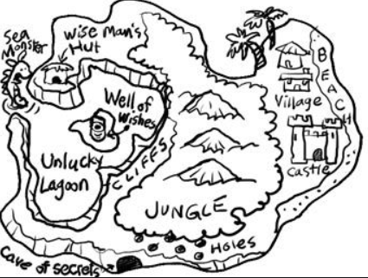 | Project 3: Science Investigations  There are three Science investigations for you to have a go at. These fun and easy science experiments are great to do at home because they require ingredients you are likely to already have in the kitchen.  The pack includes three different science experiments including a dissolving experiment, make your own lava lamp and fireworks in a glass.
Project 4: Magnificent Music Festival  Have you ever considered designing your own music festival? Which artists would you have on the line-up? What stalls and amenities would you have?  These are just some of the things that you will need to consider as your work your way through this project. | Project 5: General Knowledge Quizzes  Three quizzes each with a set of questions about a vast array of subjects, not encompassing any one particular area of knowledge, but instead a variety of.  You could even challenge your family! | Project 6: Brilliant Board Game  A homemade board game is just the thing to impress your household. Before you unveil your masterwork, you’ll have to design the basics, like goals and rules. Once that’s taken care of, you’re ready to mock up a prototype so you can test your design.

Your teacher will monitor your work through on-line tracking and whatever work you upload to your class twitter page, so remember to share your achievements with us!

