Suggested Daily Activities

9 o’clock | Morning Exercise | Join us each morning to wake up those brains!  You voted, we listened! This week, you chose to increase the pace with a more intense workout!  Click the link below and get your body moving!  KIDS ZUMBA: I like to move it, move it  Look out for more voting options next week, we’ll be asking you to cast your vote on our twitter page @DaneRoydUFS for your favourite ‘Morning Exercise’ so that we can work-out together even when we are apart!
10 o’clock | Phonics | LIVE  Letters and Sounds for Home and School  This week’s 30 minute videos will continue to focus on adjacent consonants and short-vowel sounds.  In Phase 4, no new graphemes are introduced. The main aim of this phase is to consolidate the children's knowledge and to help them learn to read and spell words which have adjacent consonants, such as trap, string and milk.  Remember all previous videos are saved on the YouTube channel so if you think your child would benefit from recapping some of the earlier sounds covered, it makes sense to consolidate before moving further.
ANYTIME

In class we are working through Phase 3 again to ensure the children’s understanding is fully embedded.
This week is a shorter teaching week due to planned INSET DAYS. As such, we have chosen to recap only 2 phonemes; the ‘oi’ and ‘ow’ sounds. Don’t forget you can download our activities from the resources section of this week’s UFS home-learning page on the school website if you wish to try this at home.
OTHER FUN WAYS TO CONSOLIDATE LEARNING

Phase 3 Real or Nonsense (select oi & ow)
Phase 3 Flashcards (select set 6)
Phase 3 Tricky Words

SPELLINGS

In class we will be practising writing Phase 3 Tricky Words. Why not download our ‘look, say, cover, write’ sheet from the resources section of this week’s UFS home-learning page on the school website and join in with us?

11 o’clock | Maths | NUMBER RESOURCES  In school we will be re-visiting the Early Learning Goal of addition, so why not download our activities from the resources section of this week’s UFS home-learning page on the school website and join in with us?  Here is a fun online game that can support your child in their learning:  https://www.topmarks.co.uk/addition/robot-addition (select addition up to 10 and progress onward)
SHAPE, SPACE & MEASURE RESOURCES

In school we will be re-visiting the Early Learning Goal of 3D shapes, so why not download our activities from the resources section of this week’s UFS home-learning page on the school website and join in with us?

Here is a fun online game that can support your child in their learning:

Shifting shapes https://www.ictgames.com/mobilePage/shiftingShapes/index.html

INSTRUCTIONS: make sure the toggle is switched to 3d, adjust the size of the torchlight using the slider on left-hand side (note: a larger torch size gives them a better chance of guessing the 3d shape), then hover the torch around the screen to see parts of the hidden shape. Can they guess what it is?

GENERAL MATHS RESOURCES

The links below are Government approved online home learning teaching resources:

Oak National Academy
Classroom Secrets
White Rose
12 o’clock | Lunch Time | This week as we eat our picnic lunch in our pods we’ll be watching Down on the Farm.  Join us to learn about where our food comes from.
1 o’clock | Afternoon Activities | MASH-UP MONDAY (music & making)  Login to your YUMU account and watch the ‘Tempo’ lesson. Tempo refers to the speed of the music. Is it fast or slow?  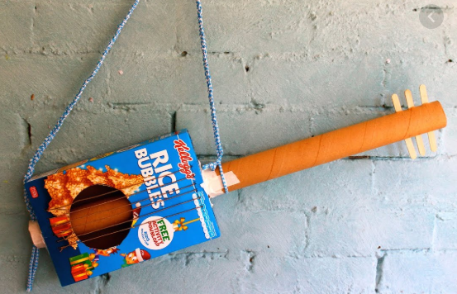  Think about some minibeasts (bee, snail, butterfly, caterpillar) Can you describe how they move? Are they fast or slow, graceful, stompy or frantic? Why not try to represent the sound of these animals with a short composition using items around the house to make some minibeast music?  Time to craft! Our story this week ‘TABBY McTAT’ features a musical cat and a busker who loves to entertain with his guitar. Make your own guitar using recycled materials and tweet us a picture!  TEST- IT TUESDAY  Just for fun, why not try to grow a Sugar Crystal Sparkler. Watch the quick tutorial here, https://www.youtube.com/watch?v=HYRbtnqvteQ and download the instructions from the resources section of this week’s UFS home-learning page on the school for further guidance.  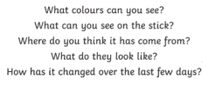  WORK-OUT WEDNESDAY  Cosmic kids Yoga : Parsnip the Cat (15 min yoga routine)  Kids Zumba: Spread love (3 min dance routine)
2 o’clock | Story Time | Each week in school we will be looking at a different story by Julia Donaldson.  This week it’s Tabby McTat  Why not download our activity booklet from the resources section of this week’s UFS home-learning on the school website and join in our fun!
Dear Parents,

We love seeing what you have been up to via your twitter posts on our class page @DaneRoydUFS so please keep them coming.

Also, don’t forget you can also include it in your child’s learning journey by simply emailing inbox@2buildaprofile.com from the email account you usually receive their half-termly observation report. It’s easy to do. Just attach your photo and type a brief description of what they have been doing. This really helps us decipher what learning has taken place and allows us to assign more accurate objectives to your observation.

Take care everyone, from the whole UFS Team x

