**Lead Personnel**: Data Protection Officer

Behaviour, Positive Handling and Exclusion policy.



**Policy Date:**

**Review Date:**

**Review Frequency:** 1 Years

**Version:** 1

**Approval by:** Standards Committee

**Lead Personnel**: Behaviour and

Inclusion Co-ordinator

**Legislation:** Annual

## Aims which guide our policies and practice

As a school, we seek to promote shared moral and ethical values to unite both local and global interests which enable children to become global citizens. Our agreed school aims are:

* To create a happy and stimulating learning environment, in which each child will develop to their full potential, thereby achieving high educational standards.
* To develop self-awareness, self-respect and tolerance of others by developing an understanding of the world in which they live.
* To appreciate human achievements and aspirations; develop aesthetic sensitivity and appreciation; physical ability and co-ordination and a concern for the safety of themselves and others.
* To prepare children to live and work with others, enabling them to be responsible and caring members of the community.
* To give children, at the end of their period of primary education, an appetite for acquiring further knowledge, experience and skills, so ensuring they are prepared for the challenges of the next stage in their education.

We ensure that all of our policies and practices are guided by these aims and we seek to ensure that they are at the forefront of all that we do.

**Behaviour, Positive Handling and Exclusion Policy**

**Aims**

We believe that all people are individuals and all are equally important. We recognise that there are differences that take many forms between individuals and groups of individuals. We respect and celebrate these differences and seek to provide opportunity for all to participate fully in the life of the school. We believe that every child has the right to learn and that good behaviour, from both the child and children around them, is essential for learning to take place.

We seek to promote an environment where we our ethos and aims are achieved though the development of:

* self-confidence and self-esteem
* academic success
* social, emotional and spiritual awareness
* mutual respect towards all
* individual responsibility
* global awareness

**Responsibilities**

**All members of the school community will work towards the overall aims by**:

* respecting the rights, values and beliefs of others
* reinforcing good behaviour through positive praise
* fostering positive and healthy relationships
* offering equal opportunities to all and celebrating difference
* rejecting all forms of bullying and harassment
* consistently applying the behaviour policy
* taking pride in the school environment
* Following reporting procedures
* being exemplary role models

**The Headteacher, Senior Leadership Team and Governors will work towards the overall aims by**:

* establishing the approach towards a positive and inclusive environment
* developing an engaging and enriching curriculum
* monitoring behaviour across school and keeping an accurate and up to date log of behaviour incidents, attendance and punctuality
* ensuring that necessary funds are there to support behaviour and inclusion

**Teaching staff will work to the overall aims by**:

* delivering the curriculum in an inclusive way that caters to the range of abilities and children in their classes
* ensuring there is appropriate challenge to enable children to fulfil their potential
* ensuring they focus on the social and emotional wellbeing of all children in the school, taking part in all relevant training to understand children’s behaviour paying particular attention to childhood trauma
* ensuring there is appropriate independence and responsibility given to children
* being exemplary roles models
* ensuring the behaviour policy is adhered to at all times
* working collaboratively with the SLT on behaviour and inclusion
* familiarising themselves with all related policies, such as, the anti-bulling policy, mental health and wellbeing policy, e-safety policy and mobile devices policy

**Children will work to the overall aims by:**

* ensuring the attend school
* conduct themselves in an appropriate manner where respect is shown to all
* caring for both the people and environment around them
* taking increasing responsibility for their learning and behaviour

**Parents will work to the overall aims by:**

* ensuring their child attends school in good health, punctually and regularly
* adhering to the wider polices that affect this one, namely the attendance policy and e-safety policy
* providing support for this policy including any discipline measures that may occur from their child’s behaviour
* participating fully in consultation evenings or any other requests by the class teacher to discuss their child’s needs, progress or behaviour
* taking an active part in their child’s learning at home
* accepting the responsibility for the conduct of their child at all times
* through adhering to the terms agreed in the Home School Agreement

**Procedures**

**Circulating and understanding the policy:**

It is expected that all who work in school see the behaviour of children as a collective responsibility and therefore all who work in school will sign to say they have read and understood this policy. Staff will be given opportunities through staff meetings and ongoing training to discuss this policy and Governors will discuss any behaviour issues as part of their regular meetings. Parents may meet first with their child’s class teacher, then the Behaviour and Inclusion Lead and the Governors should they have any concerns about this policy. The policy will be sent to all parents via parent mail at the start of each academic year and be available on the school website at all times (hard copies can be requested via the school office).

**For promoting outstanding behaviour:**

* all members of the school community will act as exemplary roles models
* the curriculum will consistently stimulate, challenge and inspire
* collaboration and independence will be used to promote responsibility
* praise and positivity will be used consistently and all schools adults should be seeking out and finding examples of good behaviour to draw others attention to
* use of stamps, stickers, house points, other staff members including SLT, written feedback, appropriate rewards in line with the safeguarding and inclusion policies such as sweets, and the celebration postcards should be used to promote examples of good behaviour
* collaboration with parents about children’s achievements should be frequent
* weekly achievement assembly will be used to promote examples of good behaviour as well as academic success
* each class teacher will give raffle tickets to children for good behaviour and at the end of every term the raffle will be drawn and five prizes worth £20 each will be given out funded by the PTA
* each class will have a star of the week and celebrated in the achievement assembly
* children will be placed in a House Team where they can collectively work towards acquiring points for the House Cup each week
* regular in class discussions and assemblies about behaviour should take place to promote positive outcomes
* Outside of school achievements should be celebrated in school as well, either in class or as part of the achievement assembly
* Using restorative justice practices (example questions can be found below)
* A robust anti-bullying policy and action plan reviewed at least anually
* Consistent approach with common sense flexibility should be applied at all times

**For eliminating undesirable behaviour:**

**EYFS:**

The EYFS curriculum places a strong emphasis personal, social and emotional development (PSED). This involves them developing a positive sense of self and others, form positive relationships and respect for other, develop social skills and manage their feelings and understand appropriate behaviour in groups.

The classroom is designed specifically to encourage the development of these skills and high expectations of behaviour are established as part of this foundation learning. Each classroom will contain a 3 step chart with each child’s name on based on a sun, cloud and rain

Children will learn from positive praise and interactions and excellent modelled behaviour however if there is undesirable behaviour they may move down the cart and receive some time away from the task. Age appropriate restorative justice will be used for the child to think about what caused the behaviour. Any serious incidents as outline below will result in the whole school sanctions being followed.

**KS1 and KS2 Classroom:**

* With minor incidents (examples below) the child will receive a verbal warning which is firm but positive and reaffirms the desired behaviour e.g. ‘I would like you facing this way and completing your work……thanks’ instead of ‘stop turning around’
* If behaviour continues the child will receive a yellow card that should be placed on their desk with a clear indication as to what behaviour needs to be demonstrated again in a firm and positive manner, the class teacher may decide to ask the child to move places, work outside or complete the task in another classroom, always focusing on the emotional wellbeing of the child
* If the behaviour continues then the child will receive a red card which will result in the loss of 20 minutes lunchtime. The child will go to the assigned classroom and explain to the teacher their reason for being there and this should be used as an opportunity for restorative practice
* If a child has persistently poor behaviour then parents should be notified and incidents should be recorded on CPOMS to make senior staff members aware and involved where necessary (this should follow the Key Stage Lead, Behaviour and Inclusion Lead, Headtecher hierarchy) and a behaviour report may be started
* Where a serious breach of behaviour has taken place then the Headteacher or member of SLT may decide in line with this policy that an internal exclusion or exclusion should take place (serious breaches can be found below)

**Playground:**

* If at playtime then teachers should implement the above system
* At lunchtimes dinner supervisors should again give clear, firm and positive instructions detailing the desired behaviour they want to see, if the behaviour continues then after the second warning they should stand the child out for 5 minutes to reflect on their behaviour, if the behaviour continues they can increase the time, serious incidents should be brought to the attention of the class teacher either at the end of lunchtime or during when appropriate.

Where undesirable behaviour does occur the staff member dealing with that situation must keep focus on the emotional wellbeing of the child. Positive relationships should try to be maintained at all times and confrontation should be avoided, this should be done by focusing on the action not the child. Serious reprimand in line with this policy and procedures found should not humiliate or degrade in any way and has been designed not to do so.

Minor incidents include but are not limited to:

* Non-compliance to a reasonable request
* Inconsiderate behaviour
* Constant chatting
* Touching others
* Disrespecting resources
* Inappropriate language
* Distracting and disturbing others
* Lying
* Unkind behaviour including name calling or showing disrespect to others
* Interrupting adults
* Damage to the physical environment

Serious incidents include but are not limited to:

* Sustained disrespect that may include racism, homophobia and sexism
* Inappropriate touching of others
* Verbal aggression
* Confrontational and deliberate defiance
* Physical assault towards another child or adult including spitting
* Continually preventing others from learning
* Breaching the e-safety policy (In line with the e-safety policy the school will search devices if we believe that anything prohibited may be on them- prohibited material includes, pornography, violent or hate filled material, anything that breaches the prevent agenda, evidence of serious incidents of bullying, pictures taken on the school premises of other children or teachers)
* Bringing harmful items into school (The school will follow procedures as defined in Section 550AA of the Education Act 1996 should we believe these items are present on the child in school and this includes electronic devices that we believe may possess any of the above mentioned material) NB. The school accepts no liability for loss or damage to any item confiscated by school

It should be noted that teachers and all paid employees with responsibility for pupils have the statutory authority to discipline pupils whose behaviour is unacceptable, who break school rules or who fail to follow reasonable instruction as set out in Section 90 and 91 of the Education and Inspection Act 2006. This allows staff to:

* Discipline pupils at any time the pupil is in school or off site whilst wearing a school uniform
* Confiscate pupils’ property
* Agree a sanction outlined in this policy
* Impose a restriction on the school day e.g. prevent them from attending an afterschool club or a loss of playtime as long as the child is given access to eat, drink or use the toilet as normal
* Impose sanctions on for serious incidents that have taken place outside of school that may have brought the school into disrepute or incidents of serious bullying/harassment that have affected another child in school

**For reporting and logging incidents:**

* The class teacher does not need to record minor incidents but should they feel that they are beginning to build they may want to record the incidents on CPOMS linked to the child to begin a record
* Serious incidents that involve violence or where the child or another has been hurt should be recorded on CPOMS and a body map completed in line with the safeguarding policy
* Any incident of racism or homophobia must be reported via CPOMS and tagged appropriately. These will automatically be followed up by a member of SLT
* Incidents that involve e-safety or bullying should be tagged as such
* Parental concerns should also be logged on CPOMS to keep a record and logged as such
* Dinner supervisors are responsible to report serious incidents to the class teacher and log them via the office on CPOMS

**For carrying out restorative justice:**

A restorative approach supports children developing the necessary skills to self-regulate their own behaviour. It allows all those involved to have their say and decide how to make the situation better. One should seek to avoid language that assumes knowledge, attributes blame or leads to confrontation. The following questions may be used:

* What happened?
* Which part were you responsible for?
* What choice did you make?
* What choice could you have made?
* What were you thinking at the time?
* What have you thoughts been since?
* Who has been affected by this and in what way?
* What do you think could make it right?
* What could have been done differently?
* Was it the right or wrong thing to do?
* Was it fair or unfair?
* What are you sorry for exactly?
* What could you do to avoid this again?

**For use of positive handling:**

All staff will complete a cycle of Team Teach Training and apply its principles in full. This requires a variety of positive deescalating approaches to correcting behaviour to take place before a physical restraint. These include but are not limited to: changing staff member dealing with behaviour, using humour when appropriate, using distraction etc. As a last resort, if a child is at immediate risk of hurting themselves, another child or adult, or going to cause serious damage to property or commit a criminal offence then a physical restraint may take place. Ideally the child will be moved to the inclusion room, away from others and to the safe environment where they can be released from the hold. Any restraint will be recorded in the bound and numbered book and the wider incident that lead to the restraint recorded on CPOMs.

**For carrying out an internal exclusion:**

In rare circumstances the SLT may deem that behaviour demonstrated by the child has been of the severity to warrant an internal exclusion. The exclusion will take place in the inclusion room and the behaviour support TA or a member of SLT will supervise the exclusion from the classroom. It is essential that again it is the actions that brought the child to that point are the focus rather than the child. Opportunities for learning must be present at all times and the class teacher should provide appropriate, stimulating work that can be completed by the child with the help of the supervising adults. It is important that the child does not see the time as a reward, however, it is vital that the emotional wellbeing of the child is maintained at all times. Opportunities for restorative practice and reflection are essential and the Behaviour and Inclusion lead will meet with the parents and child to explain why we believe the behaviour meets the threshold for an internal exclusion. THE CHILD MUST NEVER BE LEFT ALONE AND IT IS NOT TO BE ISOLATED.

**For carrying out fix term exclusions:**

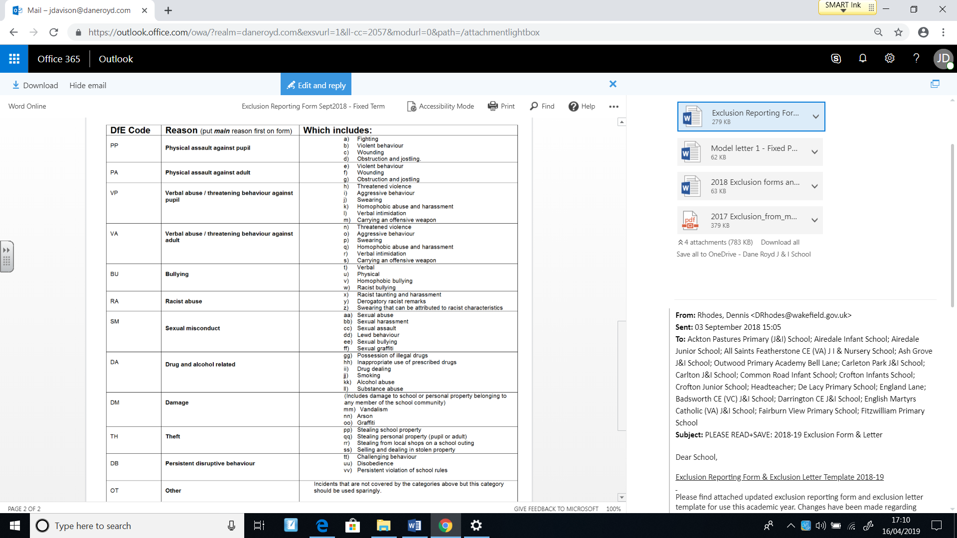In the even rarer circumstance that a child’s behaviour warrants a fixed term exclusion the SLT will follow the published government guidance that can be found in ‘Exclusion from maintained schools, academies and pupil referral units in England Statutory guidance for those with legal responsibilities in relation to exclusion September 2017’ and the Local Authority Guidelines. One of the following reason must be stated:

A reintegration meeting must take place with the parent and the child by 9 am the day the child is due back in school. This should take place with the either the TA in charge of behaviour, the Behaviour and Inclusion Lead or a member of SLT. The child should be deemed ready to return to school and again all meetings should focus on the actions and promote the emotional wellbeing of the child.

**For permanent exclusion:**

Only the Headteccher can permanently exclude in line with the previously mentioned guidance and for the most serious or continued breaches of this policy or if keeping the child in school would seriously harm the education or welfare of the pupil or other pupils in school.

It should be noted that the school promotes a fully inclusive ethos and will treat each child as an individual, recognising that some may have needs which lead to more difficulties adhering to appropriate behaviours than others, reserving the right to implement exclusions or not where we feel they will work in the best interests of the child.

**Related Policies**

This policy should be read in conjunction with the:

* Anti-Bullying policy
* E-safety policy
* Mental Health and Wellbeing policy
* Inclusion policy
* Safeguarding policy
* Special Educational Needs policy