Maths and English Activities

Expected Daily Maths Task | White Rose Maths  Daily lessons with a video and worksheet for every year group. This website provides a teaching lesson, work and answers for parents.  Year 3 website link –  https://whiterosemaths.com/homelearning/year-3/  Year 4 website link  https://whiterosemaths.com/homelearning/year-4/ | Year 3 Objectives  Monday – Right angles in shapes  Tuesday – Compare angles  Wednesday – Horizontal and vertical  Thursday – Parallel and perpendicular line  Friday – Problem Solving Challenge  Year 4 Objectives  Monday – Pounds and pence  Tuesday – Ordering money  Wednesday – Estimating money  Thursday – Four operations  Friday – Problem Solving Challenge
 | TT Rockstars  https://play.ttrockstars.com/auth/school/student | Beat your score! Practice your times tables daily.
Additional Weekly Maths Task | My Maths  https://login.mymaths.co.uk/login | Fancy revising previous learning from the year? On this website, teachers can monitor what work you have completed and set more. This in mainly consolidation of learning from earlier in the year.
Daily English Task | Oak National Academy  https://www.thenational.academy/online-classroom/year-3/english/#subjects  https://www.thenational.academy/online-classroom/year-4/english/#subjects | Monday – Skara Brae reading comprehension  Tuesday – Thursday Oak National Academy lesson sequence
 | Bedrock Learning  https://app.bedrocklearning.org/ | Continue to work your way through this fantastic on-line platform.
Additional Weekly English Task | Year 3  https://teaching.homelearning.outwood.com/primary/year-3  Year 4  https://teaching.homelearning.outwood.com/primary/year-4 | SPAG and reading tasks can be found on this on-line platform. Explore and work through at your own pace.
Spellings | Year 3  Words with the Short /u/ Sound Spelt with ou  Year 4  Adding the prefix Auto-  Resources are available on the school website | Practise your weekly spellings, set by your class teacher, using a PowerPoint presentation, fun activity and a look, cover, write check task.
Optional Topic Activities
‘The Flintstones’ (The Stone Age through to the Iron Age)
Design Technology  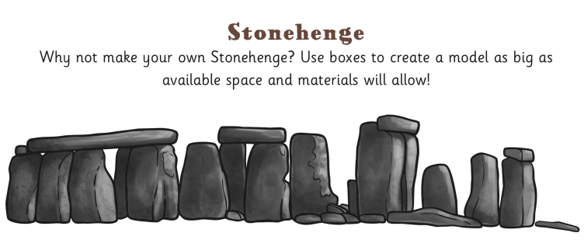  Built by our ancestors over many hundreds of years, it’s one of the world’s most famous prehistoric monuments and one of its biggest mysteries too! Can you research it and have a go at the task below? | History  Skara Brae is an incredibly well preserved Stone Age Settlement. Have a read through the PowerPoint and discuss some of the questions asked with a friend or guardian. Write any questions that you do have down and try to find out the answer! 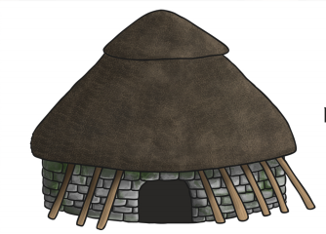 | STEM  Building Bridges Engineering Challenge!  Your challenge is to build a load bearing bridge using the materials listed on the activity sheet.  A toy car must be able to travel across the bridge.  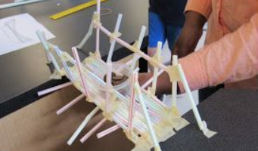
RE  Christianity – who and where did it start? Is it what you expected? Have a look at and complete the tasks. | P.E.  Challenge yourself with PE at home! Using the link below, can you complete the second and third challenges?  Use the instructions sheet to support you.  https://tlg-pe.co.uk/tlgskillsathome/ | PSHE  This month is Pride month. Have a look at the PowerPoint and see how Pride is celebrated around the world.

Your teacher will monitor your work through on-line tracking and whatever work you upload to your class twitter page, so remember to share your achievements with us!

