The Great Fire of London - KS1 Hªo°e[ŸoŒ„ Aªc[t[i[vi[t[¬e¡

P¶i]c[„ ªa[n]d ªc[h]šoÇe ¶™h[ich ªa]c[t[i[vi[t[¬e¡ ¶Ó‹u ¶Ÿou[ld ¶l[i[…e ¶t]‹ ªc]om[p[¯e[·e ¶t[h[i¡ ¶h]a[ló ¶·e[rm, colour the smiley face to show which you completed.
Ió ¶Ó‹u ¶Ÿou[l]d ¶l[i[„e ¶t]‹ ¡[h]are ¶Óou[r ¶h]o°e[ŸoŒ„ p[¯e]a¡e ¶b[ri[n]ü ¶i[t ¶i[n[t]‹ ¡]c[h]šŠl ¶b[þ Thursday 17th February 2022 or alternatively email it to
homework daneroyd.com (let the teacher know!)

Weekly tasks | Optional tasks to compliment our topic  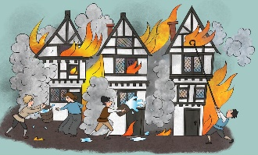
Practice your spellings lots of times in and out of order ready for spelling test every Friday. | Create a collage of a fire to represent the great fore of London. | Have a go at baking bread like they did in the bakery on Pudding Lane.
Practice the green and red word grids sent home to build your fluency and word recognition.

Read your book and ask a grown-up to comment in your yellow reading record book.  Reading books will go home on a Friday and need to be returned on a Tuesday. | Make a Tudor house from box craft to represent the houses that burnt doen on Pudding Lane.  (Not too big for display purposes!) | Keep a diary of your breakfast, dinner and tea for a week.  What do you eat lots of?  What should you eat more of?  How healthy are you?

