Drugs Policy
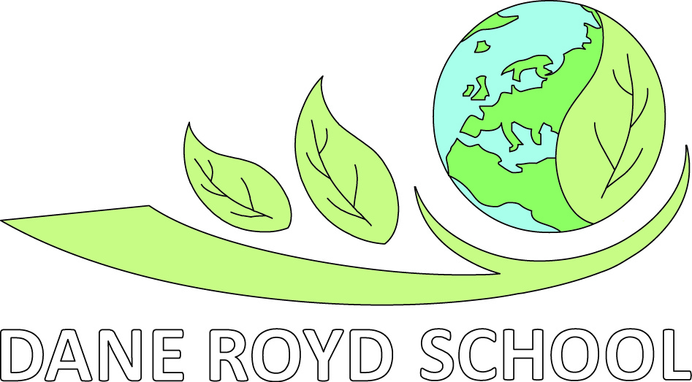
Document Date: August 2014

Review Date: August 2016
Lead Personnel: Headteacher /
SENCO
School Organisation
SEND Policy
Copy to all staff and student teachers.

Aims which guide our policies and practice
As a school, we seek to promote shared moral and ethical values to unite both local and global interests which enable children to become global citizens. Our agreed school aims are:

- To create a happy and stimulating learning environment, in which each child will develop to their full potential, thereby achieving high educational standards.
- To develop self-awareness, self-respect and tolerance of others by developing an understanding of the world in which they live.
- To appreciate human achievements and aspirations; develop aesthetic sensitivity and appreciation; physical ability and co-ordination and a concern for the safety of themselves and others.
- To prepare children to live and work with others, enabling them to be responsible and caring members of the community.
- To give children, at the end of their period of primary education, an appetite for acquiring further knowledge, experience and skills, so ensuring they are prepared for the challenges of the next stage in their education.
We ensure that all of our policies and practices are guided by these aims and we seek to ensure that they are at the forefront of all that we do.

The Philosophy of the School
The philosophy of Dane Royd Junior and Infant School is to provide a supportive and nurturing environment in which all pupils are enabled to develop educationally and personally, and which strives carefully to prepare them for opportunities, responsibilities and experiences which they may encounter in their future lives. The Policy for Drugs and Drug-Related Incidents is written in accordance with this philosophy and with other relevant school policies
- PSHE Policy.
- Behaviour Policy
- Safeguarding Policy
- Inclusion Policy

The Aims of this Policy
- To support the school’s endeavor to maintain the safety and well being of all pupils.
- To support all the members of the school community by providing clear guidance.
- To give appropriate attention to all drugs: legal drugs, medicines, solvents and other socially disapproved of drugs and illegal drugs.
- To bring clarity and consistency to the way all staff approach the subject of drugs.
- To bring about confident, effective management of all drugs on school premises.
- To set down the basis for a planned drug education programme in accordance with LA and national guidance.

Dane Royd Junior and Infant School’s Position on Drugs
This policy is intended to ensure all pupils are supported consistently whether on or around school premises and whenever the school is responsible for their welfare. We recognise that some drugs can have beneficial effects, but we also regard every drug as representing potential for harm. For this reason, all drugs need appropriate and responsible care and management. In order to be able to make informed choices, staff and pupils need to understand the nature of drugs they may come into contact with, their social and legal status and their uses and effects. These choices will include decisions about the use of medicines as well as non-medicinal drugs. It is our aim to help all our pupils to be able to take their place safely in a world where a wide range of drugs exists. The main emphasis of our work in relation to drugs is the safety of our pupils.
- Definition of the term Drugs
- Drugs are usually classified into 4 groups
  - Legal e.g. alcohol and tobacco
  - Illegal e.g. cannabis and heroin
  - Over the counter medicines e.g. paracetamol, lemsip
  - Prescription drugs e.g. insulin
- Policy construction and review

The policy has been written with careful reference to LA guidance and has involved wide local consultation. It takes into account the current level of understanding of the pupils the School, and has involved liaison with parents/carers, pupils, staff and the governing body. It will be reviewed biannually or as required. The school’s Drug Co-ordinator (SENCO) undertake the review of the policy. The policy review will monitor the usefulness and effectiveness of the policy taking into account comments and observations from:
- staff
- governors
- parents/carers
- pupils; changes in the local and national situation with regard to:
  - drug prevalence and patterns of use
  - educational guidance and identified best practice
  - and findings from our evaluation of our drug education.

School Drug Co-ordinator
The school will always have a member of staff designated as Drug Co-ordinator. Currently this is Mrs Elliott. The main function of the Drug Co-ordinator is to act as the focal point for drug issues, which concern the school. Tasks will include assessing quality and availability of in-service drug training, helping choose and purchase suitable drug education resource materials, keeping colleagues up to date with developments in the field and acting as the hub for the school’s management of drug-related situations and incidents at school. The Governor for Safeguarding is the named Governor with responsibility for school drug issues.

Drug Education
We use drug education to bring about an understanding of the drugs with which our pupils may expect to come into contact. Through drug education we aim to build their self-esteem, their skills and their belief in the significance of their own role in preserving their health and welfare. In addition to building our pupils’ competence, we also aim to build their confidence in using their knowledge and skills to make careful decisions.

At Dane Royd School, drug education is a planned and integral element of the PSHE curriculum and is an entitlement of every pupil. Staff delivering the programme are offered training and support in awareness of drugs and in the techniques of drug education. Teaching resources are chosen for their appropriate content and their quality. We recognize that all pupils need accurate, up to date, credible drug information to enable them:
- to understand what drugs are, their uses and their effects
- to be able to discriminate between categories of drugs and identify both the differences and the similarities between them.

We recognise that all pupils need;
- to acquire and practice appropriate skills
- to consider, explore (and sometimes re-consider) the attitudes and values they hold as well as those held by others
- to consider the social, health and legal issues raised by drug use
- the confidence and support to be able to cope with situations where drugs are on offer
- to believe they are unique, valuable and irreplaceable
- to believe in their own mortality
- to develop sufficient knowledge, understanding and skills to be able to preserve their own safety
- to know the boundaries set by parents/carers, school and the law
- to know where and how they can get help.

We try to assess the needs of the pupils by enquiring about their current knowledge, experiences, concerns and questions.

We deal with the subject of drugs through a planned programme and also in response to opportunities as they arise in the classroom. We revisit issues as the pupils’ awareness, readiness and experience grow with time, to build on previous learning.
We ensure that the children know the school rule that all drugs and medicines need to be managed at school by teachers and can only be brought on to school premises with teachers’ knowledge and approval. This links with our policies on Health and Safety, Behaviour and Discipline and other curricular or aspect policies, which cover drug related issues e.g. Science. As the children progress through the school, they are made aware of the relevant laws and controls that society places on the supply and use of some drugs.

The Drug Education Programme
The content of drug education will include the requirements of the National Curriculum Science Order. The following guidelines are from the new National Curriculum Science Order:
- ‘At Key Stage 2 pupils should be taught to recognise the impact of diet, exercise, drugs and lifestyle on the way their bodies function (Statutory)
Pupils should learn how to keep their bodies healthy and how their bodies might be damaged – including how some drugs and other substances can be harmful to the human body. (Non-statutory)
Pupils might work scientifically by: exploring the work of scientists and scientific research about the relationship between diet, exercise, drugs, lifestyle and health. (Non-statutory)
- Dane Royd School will teach children in Key Stage 1 about drugs in terms of medication.
- Teachers ensure that the ideas, ‘risk’, ‘danger’ and ‘harm’ are explored progressively through the school so that pupils understand the difference between taking risks and courting danger, the difference between courage and recklessness and individual differences in adventurousness. This is taught in the clear context of the emphasis we place on safety and personal responsibility.
- Our drug education programme pays attention to the development of skills and the exploration of attitudes and values as well as ensuring that drug information provided is accurate and relevant.
- Our pupils are helped to understand clearly that particular decisions about behaviour may lead inevitably to certain consequences. A range of situations and the pupils’ own experiences are used to illustrate this. This links with our PSHE policy.

Every class generates its own ground rules to support feelings of safety and security, and promote open expression of views and feelings. These are reviewed as required.

We use effective planning and monitoring to ensure a wide range of teaching strategies. The methods we use include:
- Exposition
- Role-play
- Group work
- Structured games
- Audio-visual aids
- Outside speakers

We are careful to monitor and record the drug education work done in each class and the progress the pupils demonstrate in terms of their knowledge, skills and changing attitudes. This helps us review progress and evaluate the effectiveness of our work.

Use of Outside Speakers and Visitors
We are supported in our drug education work by outside agencies such as police, school nurse, drug education development officers. We negotiate the role of all contributors so that their contribution fits our needs and they are clear what has gone before and what is expected of them. Outside speakers who come into school are used to enhance the teaching programme and not to substitute it. The class teacher is always present when visitors are working with our pupils.

Drugs on School Premises
Action will be taken in response to issues raised by situations involving drugs observed, reported or suspected beyond the boundaries of the school premises.

- Alcohol and tobacco are only allowed on to school premises in the possession of adults.
- Dane Royd Junior and Infant School is a no smoking building at all times.
- Visitors are not permitted to smoke in the buildings or on the school grounds. This is reflected in the schools ‘Policy for Smoking in School’.
- Alcohol is only permitted to be drunk by staff at school on social occasions, when no pupils are on the premises.
- Pupils are not permitted to be in possession of or use alcohol, tobacco, matches, lighters, sniffable products or any illegal drugs at any time. Pupils will be asked to turn out their pockets and parents/carers will be informed as a matter of course. If the pupils refuse we will contact parents/carers and or the police for them to come and turn out their pockets.
- Medicines must be in the care of teachers or managed by pupils with teacher supervision. Procedures accord with guidance in DfE/DoH Good Practice Guide: Supporting Pupils with Medical Needs. The authorisation and recording forms for these procedures are kept in the school office. All medication is clearly labeled with the pupil’s name and dosage and is kept in a lockable drawer in the school office. Written consent is taken from parents/carers for any medication that is to be administered. Health and medical records are updated regularly by the office staff in conjunction with class teachers and parents/carers.

Management of a Drug Related Incident
A drug related incident could include suspicion of substances being used on or off the premises, a disclosure, the finding of drug paraphernalia, parent using substances or any other incident, which the member of staff feels needs intervention or recording. All incidents should be recording as per the Safeguarding Policy and reported to a Senior Designated Person for Safeguarding.
If any pupil is thought to be under the influence of a drug, medical help will be sought at once and first aid given if required. In addition routine enquiries to try to find out what drug is involved, its source and whether any other pupils are involved will be undertaken. The priority will be pupils’ safety. Members of the teaching and non-teaching staff and CJs Playcare are qualified in first-aid.

Guidance on the Safe Handling and Collection of Sharps
The caretaker is responsible for the safe handling and collection of sharps. The sharps box and protective gloves are kept in the annex to the school office. Children are made aware that they should not touch anything that may cause them danger e.g. needles, aerosols and broken glass, and to report to an adult.

Possession of Drugs
If any pupil is found in possession of an unauthorised drug the responsible person will deal with each situation according to its severity. The Drug Co-ordinator must be informed and will take the lead in deciding how to respond further. Each situation will be judged individually. Parents/carers will normally be informed and other outside professionals such as Social Services, police, GP, schools liaison officer will be informed or consulted as appropriate. A careful investigation will be undertaken, with the Drug Co-ordinator taking the lead, to try and determine the source of any drug and the involvement of any other pupils. Careful records will always be kept. Record forms are kept in the school office and completed forms are kept locked in filing cabinet in the school office. The records will be kept up to date by the drugs co-ordinator.

The range of sanctions used for rule breaking will be similar to those for other transgressions and will depend on the nature and gravity of the offence. Exclusion will only be considered in serious cases and will be in line with DfEE and LA guidance on exclusions. A case conference will be called if it is judged necessary.

Rumours or suspicions will be fully and promptly investigated. The Drug Co-ordinator will take the lead.

Complete secrecy can never be promised to a pupil, though information given in confidence will not generally be disclosed to anyone else. In particular, if a pupil chooses to disclose in confidence that they are using a drug without medical or teacher authorisation, this information will not be used against them. However, action will be taken to ensure the pupil comes to no serious harm if this is considered a risk. Confiscation of the drug (if at school) and involvement of parents/carers are routine. Other options include:
- involvement of police
- referral to other agency, as appropriate. Referral agencies may include Social Services, Educational Welfare Officer, Schools Psychological Service, Child Guidance and Youth Counseling Service.

The effectiveness of any response to an unplanned drug incident in school will be assessed and procedures reviewed by the Drug Co-ordinator and colleagues within one week. Procedures will be amended as a result if necessary.

Geographical Boundary of the School
The school including all buildings and grounds is responsible for incidents when they happen during the day and in term time. The policy also applies when pupils are on day and residential outings from school.

The Pupils’ Needs
The needs of pupils will be considered following action to preserve safety. This will include offering support through the pastoral system and referral if necessary, to ensure a caring response to pupils in distress. Interventions will be considered if the school feels that any pupil is showing signs which indicate particular risks of, or from, involvement with drugs, whether their own or their parents/carers’. Such interventions could include consultation with parents/carers and other agencies, possible case conference and subsequent referral.

Local sources of support for pupils and parents/carers in connection with drug issues include local agencies, telephone helplines. These contact details are displayed on the general notice board outside the hall.

Inclusion
The provision of Drugs Education takes account of the different experiences, strengths and interests of the children to maintain entitlement and ensure equality of opportunity. Teachers vary the contexts, resources and teaching and learning styles and use a variety of strategies to overcome barriers to learning. Expectations and learning objectives are modified to take account of: the different learning needs of boys and girls; the needs of children from different social and cultural backgrounds; the needs of children who need support with communication, language or literacy difficulties; the needs of children with physical disability; the needs of children with emotional and behavioural difficulties and the needs of children who are gifted and talented.

Parents and Carers
The wishes of parents/carers of the school are considered carefully. We try to ensure parents/carers are aware of how we deal with drug issues and we provide drug awareness evenings as needs arise. Parents/carers are welcome to come to the school and talk to us about any concerns or questions they have.

Parents and carers are routinely contacted as soon as the school has evidence of involvement of pupils with unauthorised drugs, unless this might compromise the pupil’s safety.

There needs to be sensitivity to the possibility that parents/carers may themselves be involved with drug use in a way that raises issues of child protection.

Governors
The school has a Safeguarding Governor ready to lead on drug issues. Governors will be involved in considering and approving any changes proposed to this policy and at case conferences to consider individual pupils.

In-service Training
The Drugs Co-ordinator, is responsible for assessing the training needs of staff and for securing funds and suitable training to meet those needs.

We always try to evaluate the quality and effectiveness of training received and to disseminate useful information further at staff meetings. The Headteacher and the Drugs Co-ordinator liaise on this.

